SEQUENCES…
a_{n}=a₁ + (n - 1)d
a_{n} is the nth term, a₁ is 1st term, n is # terms, and d is common difference.

S_{n}=$\frac{n(a_{1}+a_{n})}{2}$
S_{n} is the sum of n terms, n is the # terms, a₁ is 1st term, a_{n} is nth term.
Examples:
Question | Answer
1. Find the common difference for this arithmetic sequence  5, 9, 13, 17 ... | 1.
2. Find the common difference for the arithmetic sequence whose formula is  a_{n} = 6n + 3 | 2.
3. Find the 10th term of the sequence  3, 5, 7, 9, ... | 3.
4. Find a₇ for an arithmetic sequence where  a₁ = 3x and d = -x. | 4.
5. Find t₁₅ for an arithmetic sequence where  t₃ = -4 + 5i and t₆ = -13 + 11i | 5.
6. Find a formula for the sequence  1, 3, 5, 7, ... | 6.
7. Find the 25th term of the sequence  -7, -4, -1, 2, ... | 7.
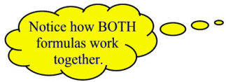  8. Find the sum of the first 12 positive even  integers. | 8.
9. Insert 3 arithmetic means between 7 and 23.  Note: An arithmetic mean is the term between any two terms of an arithmetic sequence. It is simply the average (mean) of the given terms. | 9.
10. Find the number of terms in the sequence  7, 10, 13, ..., 55.  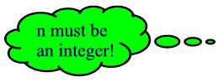 | 10.
11. A theater has 60 seats in the first row, 68 seats in the second row, 76 seats in the third row, and so on in the same increasing pattern. If the theater has 20 rows of seats, how many seats are in the theater? | 11.

1. Find the common difference for this arithmetic sequence  5, 9, 13, 17 ... | 1. The common difference, d, can be found by subtracting the first term from the second term, which in this problem yields 4. Checking shows that 4 is the difference between all of the entries.
2. Find the common difference for the arithmetic sequence whose formula is  a_{n} = 6n + 3 | 2. The formula indicates that 6 is the value being added (with increasing multiples) as the terms increase. A listing of the terms will also show what is happening in the sequence (start with n = 1).  9, 15, 21, 27, 33, ...  The list shows the common difference to be 6.
3. Find the 10th term of the sequence  3, 5, 7, 9, ... | 3. n = 10; a₁ = 3, d = 2  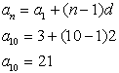  The tenth term is 21.
4. Find a₇ for an arithmetic sequence where  a₁ = 3x and d = -x. | 4. n = 7; a₁ = 3x, d = -x  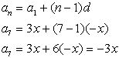
5. Find t₁₅ for an arithmetic sequence where  t₃ = -4 + 5i and t₆ = -13 + 11i | 5. Notice the change of labeling from a to t. The letter used in labeling is of no importance. Get a visual image of this problem  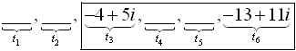  Using the third term as the "first" term, find the common difference from these known terms.  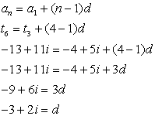  Now, from t₃ to t₁₅ is 13 terms.  t₁₅ = -4 + 5i + (13-1)(-3 +2i) = -4 + 5i -36 +24i  = -40 + 29i
6. Find a formula for the sequence  1, 3, 5, 7, ... | 6. A formula will relate the subscript number of each term to the actual value of the term.  Substituting n = 1, gives 1.  Substituting n = 2, gives 3, and so on.
7. Find the 25th term of the sequence  -7, -4, -1, 2, ... | 7. n = 25; a₁ = -7, d = 3  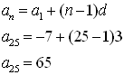
8. Find the sum of the first 12 positive even  integers. | 8. The word "sum" indicates the need for the sum formula.  positive even integers: 2, 4, 6, 8, ...  n = 12; a₁ = 2, d = 2  We are missing a₁₂, for the sum formula, so we use the "any term" formula to find it.  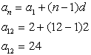  Now, let's find the sum:  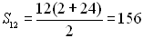
9. Insert 3 arithmetic means between 7 and 23.  Note: An arithmetic mean is the term between any two terms of an arithmetic sequence. It is simply the average (mean) of the given terms. | 9. While there are several solution methods, we will use our arithmetic sequence formulas.  Draw a picture to better understand the situation.  7, ____, ____, ____, 23  This set of terms will be an arithmetic sequence.  We know the first term, a₁, the last term, a_{n}, but not the common difference, d. This question makes NO mention of "sum", so avoid that formula.  Find the common difference:  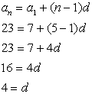  Now, insert the terms using d.  7, 11, 15, 19, 23
10. Find the number of terms in the sequence  7, 10, 13, ..., 55. | 10. a₁ = 7, a_{n} = 55, d = 3. We need to find n.  This question makes NO mention of "sum", so avoid that formula.  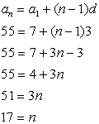  When solving for n, be sure your answer is a positive integer. There is no such thing as a fractional number of terms in a sequence!
11. A theater has 60 seats in the first row, 68 seats in the second row, 76 seats in the third row, and so on in the same increasing pattern. If the theater has 20 rows of seats, how many seats are in the theater? | 11. The seating pattern is forming an arithmetic sequence.  60, 68, 76, ...  We wish to find "the sum" of all of the seats.  n = 20, a₁ = 60, d = 8 and we need a₂₀ for the sum.  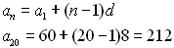  Now, use the sum formula:  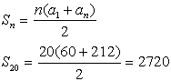  There are 2720 seats.

